**Assignment -2**

Python Programming

|  |  |
| --- | --- |
| Assignment Date | 27 September 2022 |
| Student Name | Anantha Kirishnan S |
| Student Roll Number | 412519104005 |
| Maximum Marks | 2 Marks |

**Question-1:**

Download dataset

Solution:

import numpy as np

import pandas as pd

import matplotlib.pyplot as plt

import seaborn as sns

from sklearn.preprocessing import LabelEncoder

from sklearn.model_selection import train_test_split

df=pd.read_csv('/Churn_Modelling.csv')

df.head()

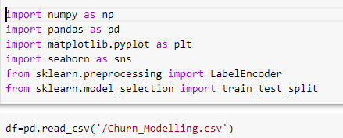

Question 2:

Dataset details

Solution:  
 df.head()

df.describe()

df.info()

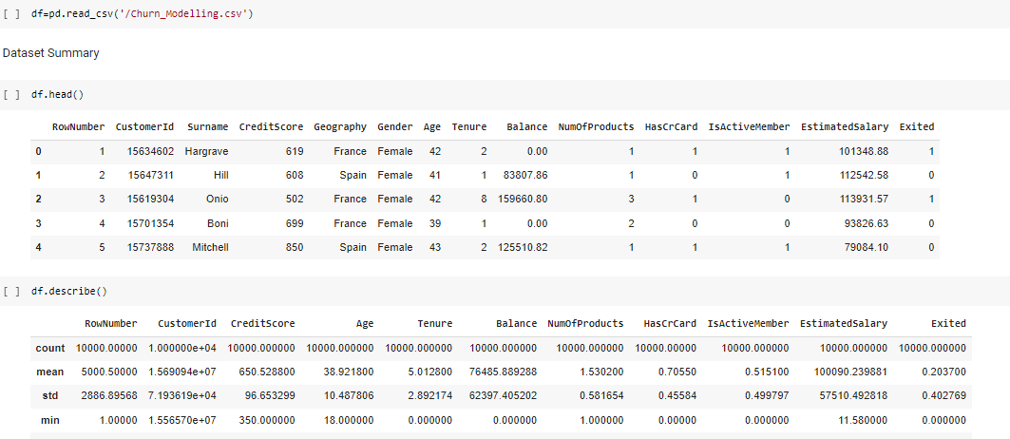

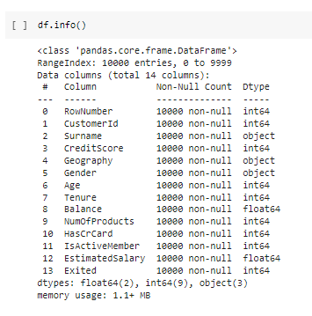

Question 3:

Plot of dataset details and etc

Solution:  
 sns.distplot(df.Age)

sns.distplot(df.CreditScore)

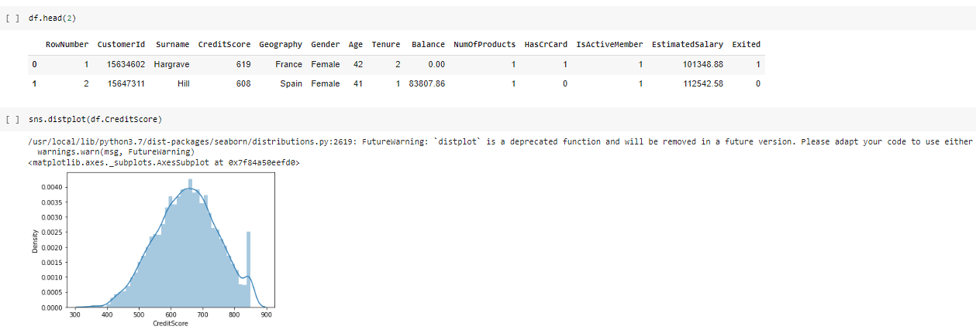

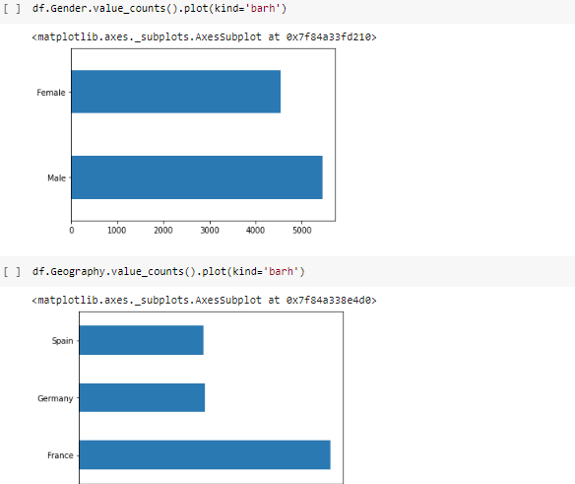

Question 5:

dataset pairplot

Solution:  
 sns.pairplot(df)

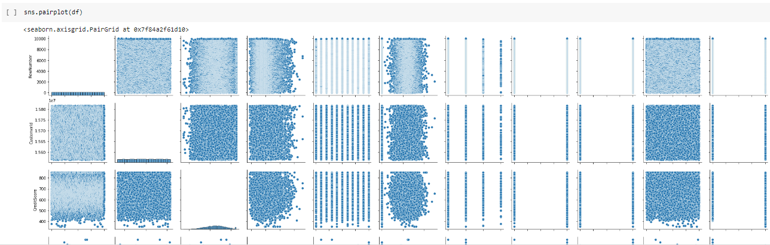

Question 6:

Heat map of dataset features

Solution:  
 plt.figure(figsize=(8,5))

sns.heatmap(df.corr(),annot=True)

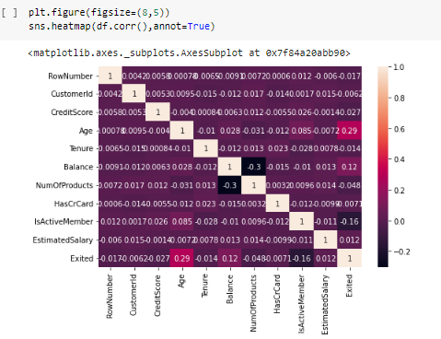

Question 7:

Explotary data analysis

Solution:  
 df.Exited.value_counts()  
 df.isnull().sum()

df.head(2)

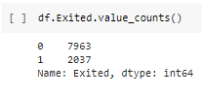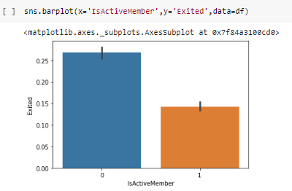

Question 8:  
 Boxplot

Solution:  
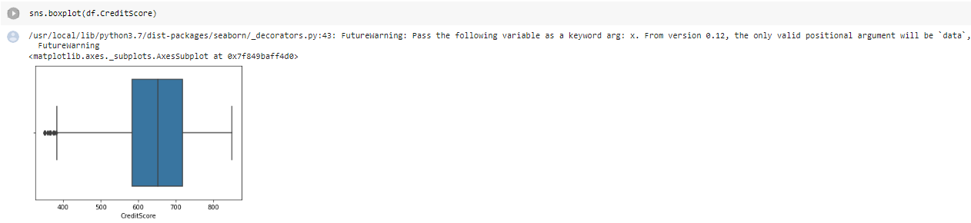

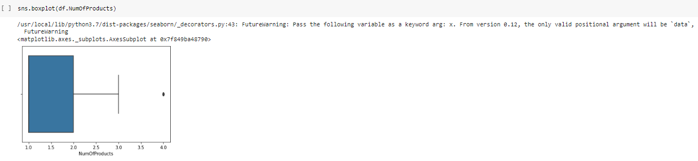

Question 9:  
dataset info

solution:  
 df.info()

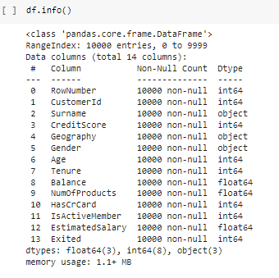

Question 10:  
Preprocessing

Solution:

from sklearn.preprocessing import LabelEncoder

le_geo = LabelEncoder()

le_gen = LabelEncoder()

df['Sex']=le_gen.fit_transform(df.Gender)

df['Country']=le_geo.fit_transform(df.Geography)

df.drop(['Geography','Gender'],axis=1,inplace=True)

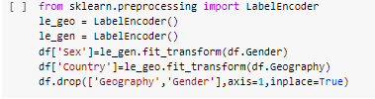

Question 11:

Preprocessing 1

Solution:

from sklearn.preprocessing import StandardScaler

sc=StandardScaler()

X = sc.fit_transform(X)

